EEE3096S Practical 1B Report

Mandelbrot Benchmarking on STM32F0

Course Code: EEE3096S 2025

Student Name: SMTROS022

# 1. Introduction

The purpose of this practical was to evaluate the performance of fixed-point versus floating-point implementations of the Mandelbrot set algorithm on an STM32F0 microcontroller. The exercise demonstrates the trade-offs between execution time and numerical accuracy in embedded systems.

# 2. Methodology

The STM32F051 microcontroller was programmed to compute the Mandelbrot set at increasing resolutions. Two implementations were created: one using fixed-point arithmetic, and one using double-precision floating-point arithmetic. The execution time was measured using the HAL_GetTick() function, and the resulting checksums were compared with a Python reference implementation.

# 3. Results

|  |  |  |  |  |
| --- | --- | --- | --- | --- |
| Resolution | Checksum (Fixed) | Time (ms, Fixed) | Checksum (Double) | Time (ms, Double) |
| 128x128 | 429,346 | 120,233 | 429,384 | 121,167 |
| 160x160 | 669,809 | 187,812 | 669,829 | 190,457 |
| 192x192 | 966,227 | 271,123 | 966,024 | 274,594 |
| 224x224 | 1,315,085 | 369,171 | 1,314,999 | 374,222 |
| 256x256 | 1,715,815 | 481,974 | 1,715,812 | 485,450 |

Table 1: Execution time and checksum comparison between fixed-point and double precision.

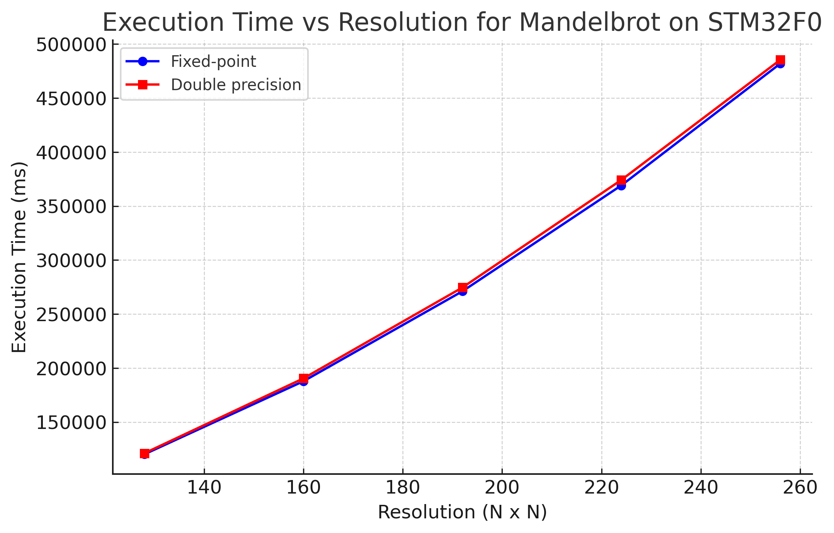

Figure 1: Execution time vs resolution for Mandelbrot computation on STM32F0.

# 4. Discussion

The results demonstrate that fixed-point arithmetic consistently executes faster than double precision, though the difference is relatively small on the STM32F0 microcontroller. Checksums indicate that both methods produce nearly identical results, with only minor differences appearing at higher resolutions due to numerical rounding. This shows that fixed-point arithmetic is a practical choice in resource-constrained embedded systems, especially when floating-point hardware is not available.

# 5. Conclusion

This practical demonstrated the trade-off between fixed-point and floating-point implementations of the Mandelbrot set algorithm. Fixed-point provided marginally faster execution times while maintaining accuracy close to that of double precision. Both methods successfully produced Mandelbrot sets with consistent checksums, validating the correctness of the implementations.

# 6. Appendix: Source Code

Below is the relevant C implementation (main.c) and Python reference script (Mandelbrot.py).

C Source (main.c):